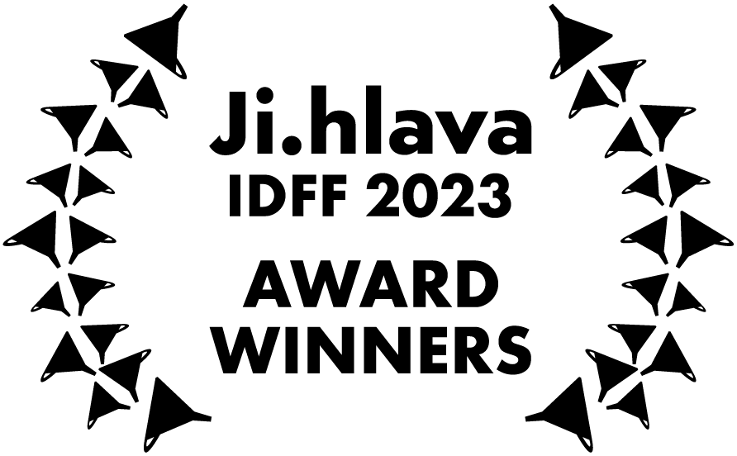
27TH JI.HLAVA INTERNATIONAL DOCUMENTARY FILM FESTIVAL AWARDS 2023

OPUS BONUM
Best World Documentary Film 2023

Winner:
Ship (dir. Elvis Lenić / Croatia, 2023)

Jury statement:
For creating a sweeping, deeply researched and visually stunning account of a Croatian shipyard whose rise and fall reflect the political fortunes of the former Yugoslavia.

Best Central and East European Documentary Film:
Distances (dir. Matej Bobrik / Poland, 2023)

Jury statement:
For producing an intimate, unflinching depiction of a single family struggling to survive the wrenching experience of migration – from Nepal to Poland.

Best Film from the Visegrad region:
The Third End of the Stick (dir. Jaro Vojtek / Slovakia, 2023)

Jury statement:
For offering a richly nuanced mosaic of life within some Slovak Roma settlements, focusing on the daily struggles for financial, physical and psychological well being.

Best debut:
You Will Never See It All (dir. Štěpán Pech / Czech Republic, Slovakia, 2023)

Jury statement:
For the creation of a complex portrait of a visual artist that succeeds in representing the intensity and variety of the work, the shock of the artist’s premature death and its impact on the family who survive him.

Award for original approach:
East Wind (dir. Maia Gattás Vargas / Argentina, 2023)

Jury statement:
For the creation of a filmmaker’s cinematic search for a father she never knew, an exploration that couples poetry with politics via the reclamation of her Palestinian cultural identity.

Students jury award:
La Reine (dir. Nikola Klinger / Czech Republic, 2023)

Jury statement:
This film combines captivating visuals, sensitive storytelling, and interaction between the director and protagonists. It creates a space for sharing personal traumas and opens up timeless themes of freedom, rebellion, and life on the edge of society.

CZECH JOY
Best Czech Documentary Film 2023

Main Award:
Photophobia (dir. Ivan Ostrochovský, Pavol Pekarčík / Slovakia, Czech Republic, Ukraine, 2023)

Jury statement:
From the appalling reality of the Russian invasion of Ukraine the authors of the film created a poetic and cinematically impressive vision of the childhood world. We value the courage to film in such challenging conditions. Through scenes of personal tragedies, the form of the film Photophobia establishes the unbreakable will of the heroic people of Ukraine to persevere and to prevail. The universal dimension of the film urgently reminds us of the scale and extent of other war conflicts, from the refugee crisis to the horror in Gaza, which test not only the attitudes of filmmakers, but also the conscience of Europe.

Special mention:
My Paradise Is Darker Than Your Hell (dir. Kateřina Dudová / Czech Republic, 2023)

Jury statement:
A raw and uncompromising exploration of the roots of self-destructiveness.

Best editing:
Satan Among Us (dir. Martin Ježek / Czech Republic, 2023)

Jury statement:
For performative editing of parasitic qualities.

Best Sound design:
Satan Among Us (dir. Martin Ježek / Czech Republic, 2023)

Jury statement:
For the Faustian vibrations of the collective shadow.

Best cinematography:
Bedwetter (dir. Jan Hušek / Czech Republic, 2023)

Jury statement:
For cinematography that connects the failed attempts of maturing from a boy into a man with the motion of a falling pinecone.

Award for original approach:
Notes from Eremocene (dir. Viera Čákanyová / Slovakia, Czech Republic, 2023)

Jury statement:
The film is a powerful personal testament which critically examines such urgent phenomena as the ongoing climate crisis or the rapid development of technology. The director sends her message into the future – which, though uncertain, is shaped by all of us. Here and now.

Students jury award:
The World According to My Dad (dir. Marta Kovářová / Czech Republic, Slovakia, 2023)

Jury statement:
A playful film addressing a topical theme, in which the author narrates with unprecedented charm the complicated journey of a father and daughter in search of enlightenment for the whole world.

TESTIMONIES
Best Film Testimony 2023

Main Award:
MIGHTY AFRIN: In the Time of Floods (dir. Angelos Rallis / France, Greece, 2023)

Jury statement:
A powerful story of a resilient young girl challenged with the loss of her home and family due to rising water levels which gives us a deep insight into the fate of hundreds of millions of people facing the consequences of climate change.

Special mention:
One Of The Thousand Hills (dir. Bernard Bellefroid / Belgium, 2023)

Jury statement:
After the worst genocide since WWII we see difficult a delicate process of peace and forgiveness.

Special mention:
Not That Kind Of Guy (dir. Signe Rosenlund-Hauglid / Norway, 2023)

Jury statement:
The topic in the essence transcends beyond sexual relationship to general male-female personal interaction. Representing both perspectives of victims and perpetrators.

FASCINATIONS
Best Experimental Documentary Film 2023

Main Award:
Silhouette (dir. Yoshiki Nishimura / Japan, 2023)

Jury statement:
Using the technical tools of recording and then analysing the world around us, the film gives us the chance to experience something as ordinary as a morning walk with the dog. The light imprints a shadow on the pavement, leaving a mark of a daily meditation. The scanning of reality becomes a poetic gesture that brings an irreplaceable experience of confronting the world around us.

Special mention:
BLUE (dir. Violena Ampudia Rodriguez / Cuba, Belgium, 2023)

Jury statement:
A piece of visual poetry processing the incredibly tough and still often taboo subject of postpartum depression, and in doing so becomes a tool to help the women themselves. A participative therapy session that takes you through the surface of sound and in turn allows the audience to immerse themselves in a 16 min snippet of a women's personal story.

Special mention:
Dinosauria, We (dir. Maxime-Claude L'Écuyer / Canada, 2023)

Jury statement:
The unsettling flow of fast-paced archival images immediately and irreversibly draws the viewer into a post-apocalyptic vision of a possible future that grows inevitably closer with each passing year. An unstoppable 35mm explosive charge.

FASCINATIONS: EXPRMNTL.CZ
Best Czech Experimental Documentary Film 2023

Main Award:
The Commodity Catalogue (dir. Zbyněk Baladrán / Czech Republic, 2023)

Jury statement:
A film whose visuality thematises itself, bringing us an almost physical experience through the cataloguing of concepts that constantly and repeatedly question themselves. A VHS uroboros that endlessly absorbs its own self.

Special mention:
But Not for Ever (dir. Anežka Horová, Klára Trsková / Czech Republic, Portugal, São Tomé and Príncipe, 2023)

Jury statement:
A twofold walk through the places of memory shows in a subtly poetic way how fragile the world around us can be. Unforgettable images of a greenhouse where nature takes back its own and literally defeats the dictatorship that we know is often around us. But not forever.

Special mention:
One Sol in the Life of Curiosity (dir. Vít Růžička / Czech Republic, 2023)

Jury statement:
24 hours, 39 minutes and 35 seconds. One Sol, during which the author lets us empathically experience the inner and outer journey of an aging rover on Mars, whose view of the great unknown tells us much more about ourselves than any scientific research.

AUDIENCE AWARD 2023

Is There Any Place For Me, Please? (dir. Jarmila Štuková / Czech Republic, 2023)

CONTRIBUTION TO WORLD CINEMA AWARD

Béla Tarr

BEST VIRTUAL REALITY AWARD 2023

Main Award:
Missing Pictures: Naomi Kawase (dir. Adriaan Lokmaan / France, United Kingdom, Taiwan, South Korea, Luxembourg, 2022)

Special mention:
Flow VR (dir. Vít Růžička / Netherlands, France, 2023)

Special mention:
The Man Who Couldn't Leave (dir. Singing Chen / Taiwan, 2022)

